Samuel Ogunfunmi

Purpose: Solve the following problems using selection/conditionals.

Date: 9/26/20

**Problem 1)**

**1. Algorithm (Solution Plan for the Problem):**

1. Capture 3 scores from user in main
2. Create a function called average
3. In the average function, find the average of the 3 values captured in main.
4. Return the Avg score value to main
5. In main, determine if user has an avg score over 70
6. Let user know if they pass or fail

**2. Program Source Code (copy and paste from IDE):**

def calcAverage(score1,score2,score3): #fucntion made to find the average of 3 numbers

avg = (score1 + score2 + score3) / 3

return avg #Returns result of 3 inputs averaged to main

def main():

print("Enter test scores\n") #Tells user to enter test scores

score1 = float(input("First score: ")) #asks user for number

score2 = float(input("Second score: ")) #asks user for number

score3 = float(input("Third score: ")) #asks user for number

score_avg = calcAverage(score1,score2,score3)

if score_avg >= 70:

print("Your have a passing grade.")

else:

print("Your do not have a passing grade.")

main()

**3. Program Output Screenshots/Screen Print(s) and/or Error Messages:**

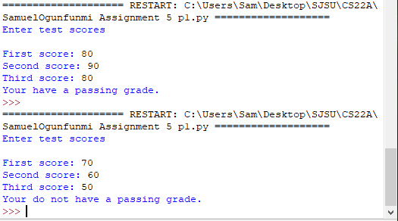

**Problem 2)**

**1. Algorithm (Solution Plan for the Problem):**

1. Establish the grade thresholds as variables
2. Ask the user for test score
3. Use if/elif statement to determine the user’s grade.
4. Print users grade

**2. Program Source Code (copy and paste from IDE):**

def main():

A_grade = 90

B_grade = 80

C_grade = 70

D_grade = 60

test_score = float(input("Enter your test score: ")) # Ask user for test score

# Determine the grade.

if test_score >= 90:

print("Your grade is A.")

elif test_score >= 80:

print("Your grade is B.")

elif test_score >= 70:

print("Your grade is C.")

elif test_score >= 60:

print("Your grade is D.")

else:

print("Your grade is F.")

main()

**3. Program Output Screenshots/Screen Print(s) and/or Error Messages:**

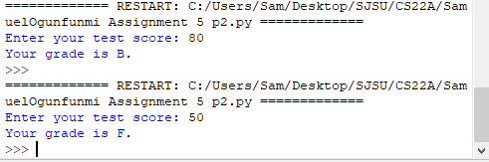

**Problem 3)**

**1. Algorithm (Solution Plan for the Problem):**

1. Print a menu that allows user to select the type of conversion they want to run
2. Create conversion functions for Celsius to Fahrenheit and vise versa
3. Use if statements in main for the user to select the type of conversion
4. Print converted temp for the user

**2. Program Source Code (copy and paste from IDE):**

def C_to_F():

Celsius = input("What is the temperature in Celsius? ")#Input from the user

C = float(Celsius) #makes input a float

Fahrenheit = ((C * 9/5) +32)#Converts C to F

print ("This temperature in Fahrenheit is ", Fahrenheit, " degrees") #Prints converted temperature

def F_to_C():

Fahrenheit = input("What is the temperature in Fahrenheit? ")#Input from the user

F = float(Fahrenheit)

Celsius = ((F-32) * 5/9) #Converts F to C

print ("This temperature in Celsius is ", Celsius, " degrees") #Prints converted temperature

def main():

print("1. Celsius to Fahrenheit") #option 1

print("2. Fahrenheit to Celsius") #option 2

option = int(input("Select which number conversion you would like to run: ")) #ask user to select an option

if option == 1: #if user selects option 1 run the Cel to Fah conversion

C_to_F()

if option == 2: #if user selects option 2 run the Fah to Cel conversion

F_to_C()

main()

**3. Program Output Screenshots/Screen Print(s) and/or Error Messages:**

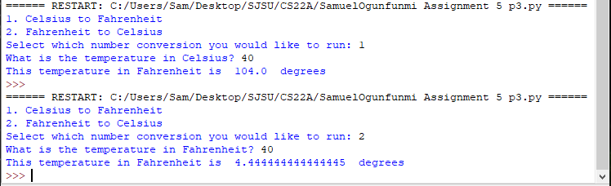

**Problem 4)**

**1. Algorithm (Solution Plan for the Problem):**

1. Print instructions for the user
2. Ask the user to enter in month, date, and year
3. Multiply the month and date inputs to find the magic number
4. User if statement to determine if the magic number is the same as the year entered.
5. Let the user know if the date is a magic date or not

**2. Program Source Code (copy and paste from IDE):**

def main():

print("Enter a date using numeric values \nFor example: June 10, 1960 would be written as 06/10/60 \n") #prints instructions

month = int(input("Month: ")) #ask user for month date year

date = int(input("Date: ")) #ask user for date

year = int(input("Year: "))#ask user for year

magic_number = (month*date)

if magic_number == year:

print("This is a magic date")

else:

print("This date is not a magic")

main()

**3. Program Output Screenshots/Screen Print(s) and/or Error Messages:**

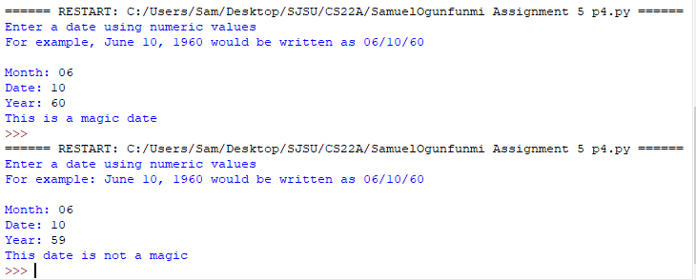

**Problem 5)**

**1. Algorithm (Solution Plan for the Problem):**

1. Ask the user for their weight and height
2. Find the user’s BMI using a formula
3. Use if statement to determine if the user is underweight, overweight, or at an optimal weight

**2. Program Source Code (copy and paste from IDE):**

def main():

weight = float(input("Enter weight in pounds: "))

height = float(input("Enter height in inches: "))

BMI = weight * 703 /(height ** 2) #Calculates BMI

print (BMI, "is your BMI")

if BMI < 18.5:

print("You are underweight.")

elif BMI <= 25:

print("You are at an optimal weight.")

else:

print("You are overweight.")

main()

**3. Program Output Screenshots/Screen Print(s) and/or Error Messages:**

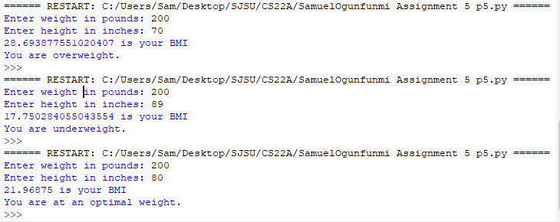

**Conclusion/What you learned writing this program and what problems you encountered.**

I learned how to use multiple if statements and gained more experience using functions to solve problems.